# ASSIGNMENT-I

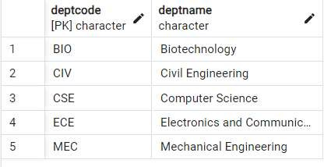CREATING THE REQUIRED TABLES

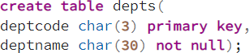

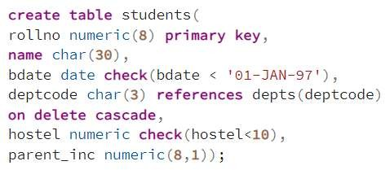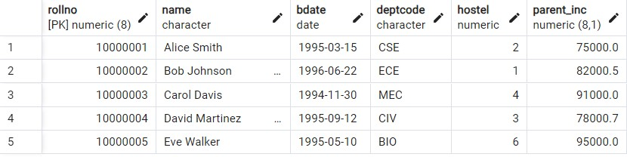

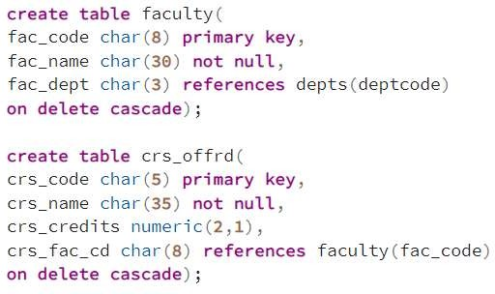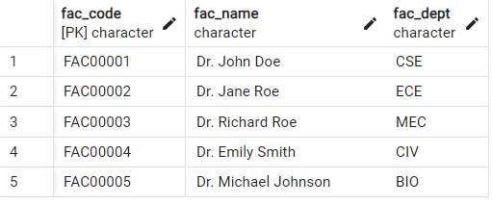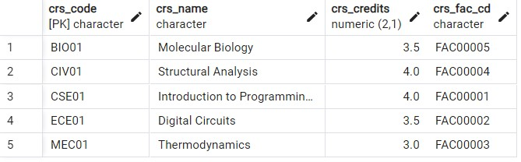

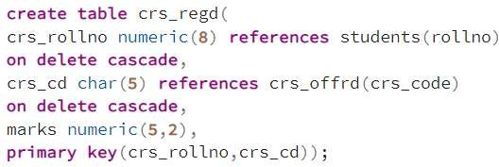

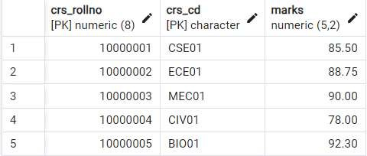

## Inserting records which violates the constraints.

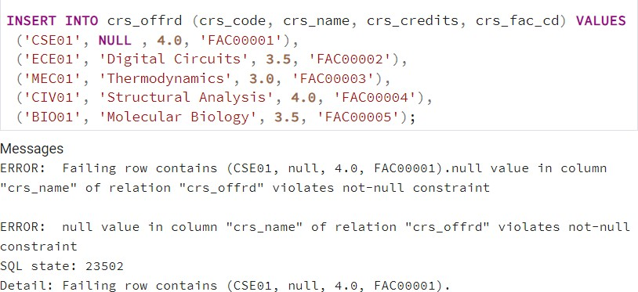

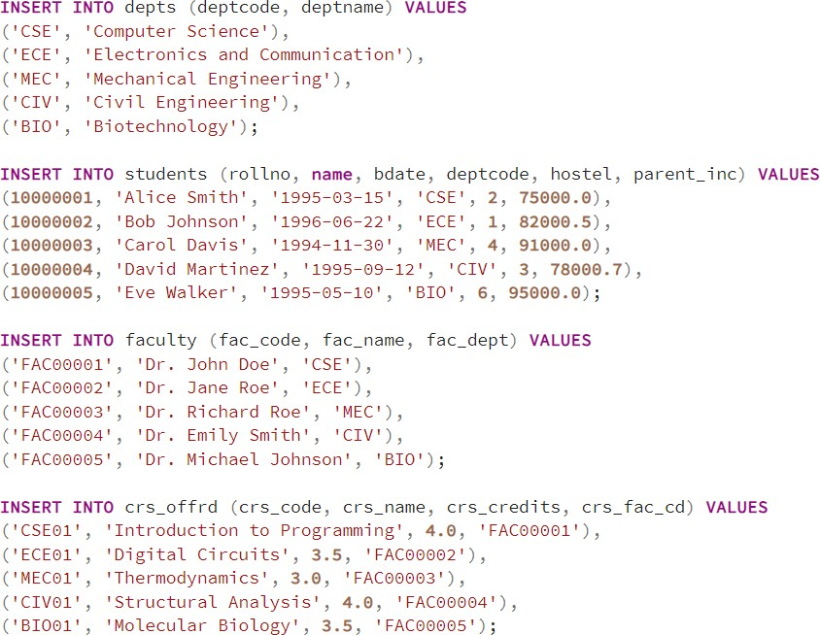

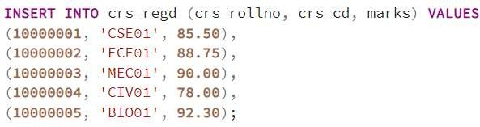

Delete records from dept where deptcode='CSE'.

(This deletes records from students whose deptcode='CSE')

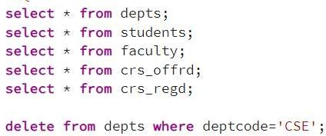

Find out the courses offered by the faculty dbp and nls.



Find out the courses with full details offered by dbp.



Get the courses the credits of which lies between 4.0 and 6.0.



Get the courses the credits of which are > 6.5.



# ASSIGNMENT-II

Count the number of students in CSE dept.



Determine the minimum, maximum and average marks of each courses.



Determine the total credits of the courses registered by a student.

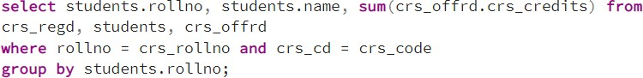

Count the number of students in each hostel whose department is CSE.



Display the hostel,rollno,parent_inc of the student who has the max(parent_inc) in a hostel.



Display the name and parental income of each student greater than the parental income of some rollno 92005010.



Find out marks of students who have marks more than rollno 92005102 for course CH103 and PH106.



# ASSIGNMENT-III

List students (rollno,name,deptcode) registered for course EE101.

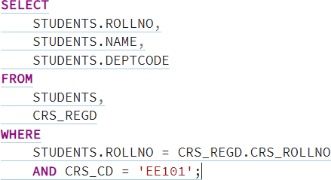

List students (rollno,name) in ELE dept registered for course EE101.

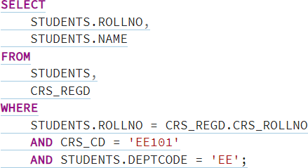

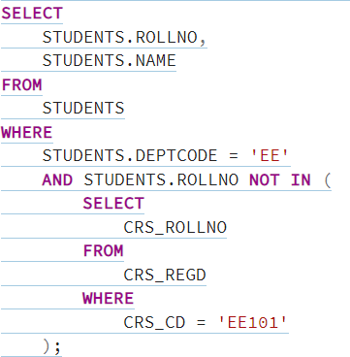List students (rollno,name) in ELE dept not registered for course EE101.

List the names of the students who have registered for both the courses 'DBMS' and 'OS'.

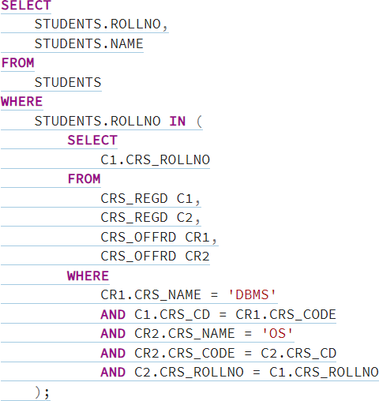

Find the names of the faculty members who have offered either 'MIS' or 'Software Engg.'

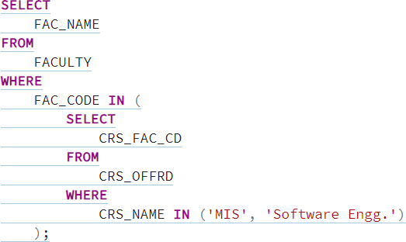

Find the names of the faculty members who have offered 'MIS' but not offered 'Software Engg.'

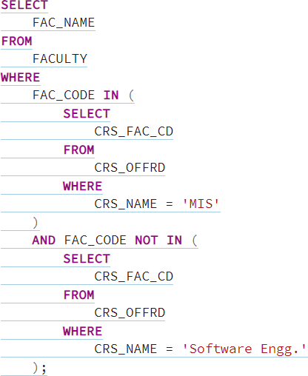

Find out the students in each hostel who are not registered for any course.

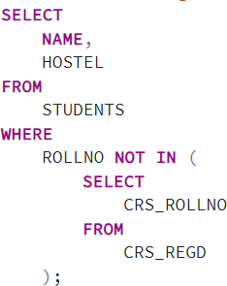

Select the students who are in ELE dept or who have registered for course CS101.

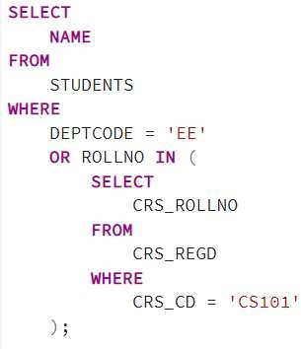

Display the students who have registered to all the courses.

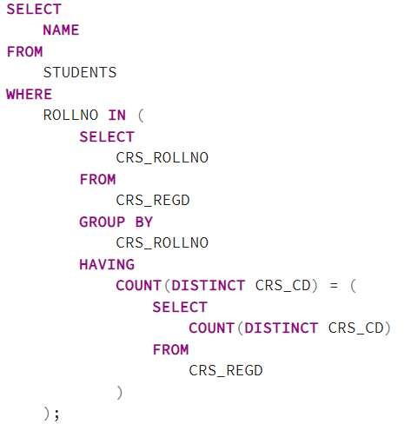

Give Grace Marks 5 in subject ‘DBMS’to the students who have scored less than 50 in that subject.

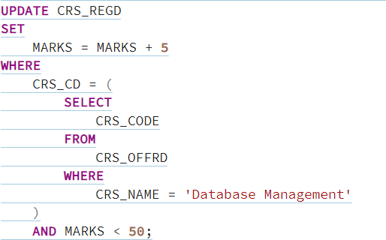

# THANK YOU